BUILDING GUIDE – POLE BARN CONSTRUCTION

TOWN OF SPRINGWATER, NEW YORK

What is a pole barn?

A pole barn is simply a barn that is constructed with support poles that serve as the underlying support structure for the outer walls and roof. In most cases, the poles are beams of wood, rather than metal, which may be what normally comes to mind with the term pole. In addition to the pole barn, the pole shed is also common. These storage sheds can be found both in rural areas and urban settings.

The pole barn has some features that are common to nearly all models. First, the poles are nearly all wood. Second, the shell of the barn is usually metal. Together, the two materials work to produce a structure that is suitable for both livestock and additional storage.

In some cases, a concrete foundation will be added to the pole barn. However, there are many pole barns that have a simple dirt floor as well. The advantage to the dirt floor is mainly one of cost. The main disadvantage is it can more easily become susceptible to unwanted animals and insects, though these usually find their way into barns with concrete floors as well.

Many people, especially those who farm or who are good with their hands, may attempt to build a pole barn all by themselves, with the help of friends and family. This may be a relatively simple task, especially when compared to other types of structures. Pole barn plans are readily available from a number of different sources and some will even help the builder by delivering supplies and materials or arranging for their delivery.

How to use this guide:
To help our builders, we have created this guide to streamline the building permit process but in a manner that assures compliance with the Uniform Fire Prevention and Building Codes of New York State. With this in mind, please complete the following:
- Complete this building guide by filing in the blanks on all pages.
- Provide a site plan showing dimensions of your pole barn and its relationship to existing buildings or structures on the property as well as the distance to existing property lines.
- Fill out and sign the building permit application. The majority of permit applications are processed with little delay. The submitted documents will help determine if the project is in compliance with building safety codes, zoning ordinances and other applicable laws.

Disclaimer:
This guide was developed as a basic plan submittal to streamline the building permit review process
and improve communication between the builder and code officer. It is not intended to cover all circumstances and additional information that might be needed depending on the scope of work. For this reason contact us at (585) 447-0249 or email to springwatercodes@yahoo.com if questions arise.

Reminder:
NYS Law requires all buildings which are larger than 1500 sq. ft. or cost more than $20,000 requires a stamped set of plans from a Professional Engineer or Architect.
Page 1 of 6

Plan requirements:
Please provide all of the details listed below on your plans. One complete set of plans shall be submitted at the time of the application.

Floor plan:
- Provide plan view of pole location, spacing and dimensions of the building.
- Framing plan should show direction, size and spacing of the roof system, purlins, girts, beams and header sizes.
- Indicate the locations of all window and door openings.
- Indicate the locations of the poles and provide dimensions between poles.

Section elevation:
- Front, rear and both side views to scale.
- Finished grade line at building.
- Label the depths to the bottom of the poles. Please recognize that the piers must be at least 48 inches in depth, which is the frost depth in this area.
- Label the pole size and type of material. Wood poles embedded in earth must be treated wood, labeled for ground contact.
- Label the sidewall girt size, type of material and spacing. The bottom girt must be treated wood, labeled for ground contact.
- Label the beam size and type of material above the poles. Detail the method of fastening the beam to the poles.
- Label the rafter size and spacing. If engineered trusses are to be used, you must indicate this instead and provide a truss certificate at the time of the application.
- Label the rafter tie (or ceiling joist) size and spacing. This is not required for engineered trusses.
- Label the roof purlin size and spacing, if applicable.
- Label the exterior wall finish material.
- Label the roof covering material.

Inspections required:
- Setback and pole hole inspection. After the holes are dug but before concrete pads are poured.
- Concrete floor inspection. After the gravel is prepared and reinforcing steel (e.g., welded wire mesh) is installed. Concrete shall be a minimum of 3500 psi, air entrained concrete.
- Framing inspection. After the building is up and before any insulation or interior covering is installed. May be final also if no other work is being done.
- Electrical inspection. All electrical work shall be inspected by an approved, third party electrical inspection agency – not the Town inspector. Please refer to the building permit application for more information.
- Final inspection. Requested after all work is completed such as, but not limited to, insulation, concrete slab, electrical, plumbing, heating and/or sheet rock

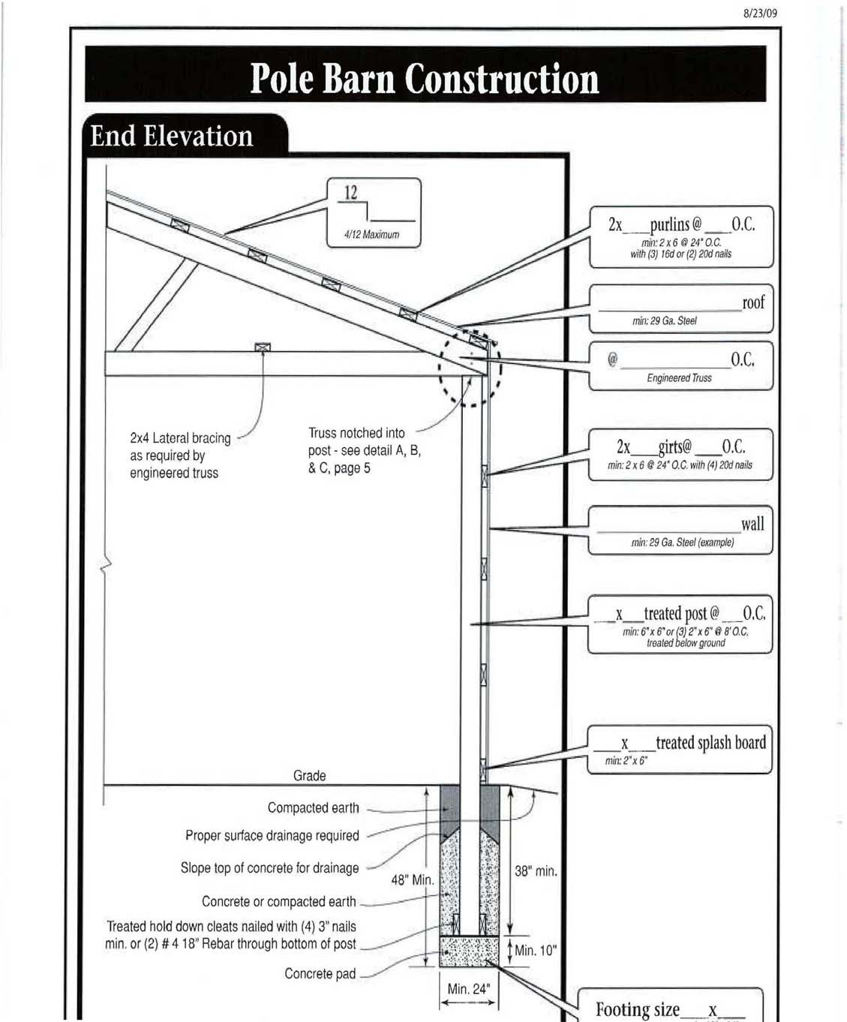

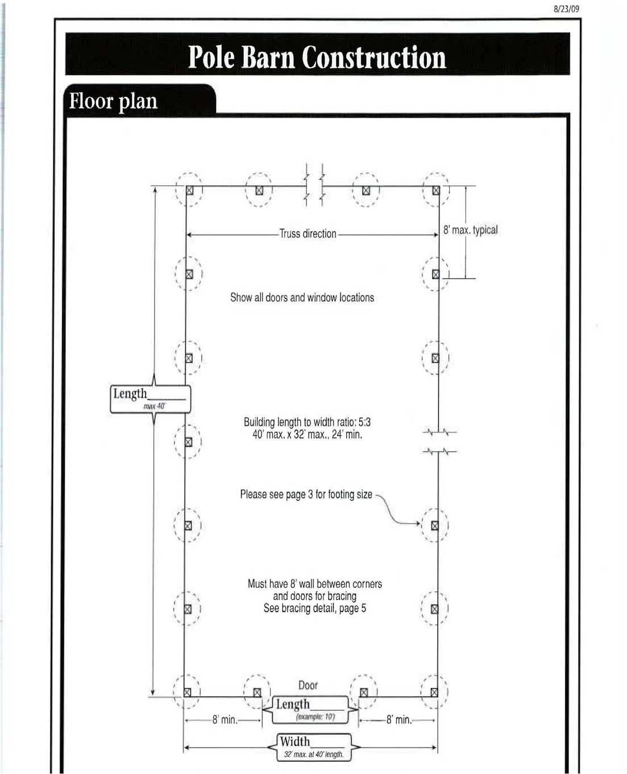

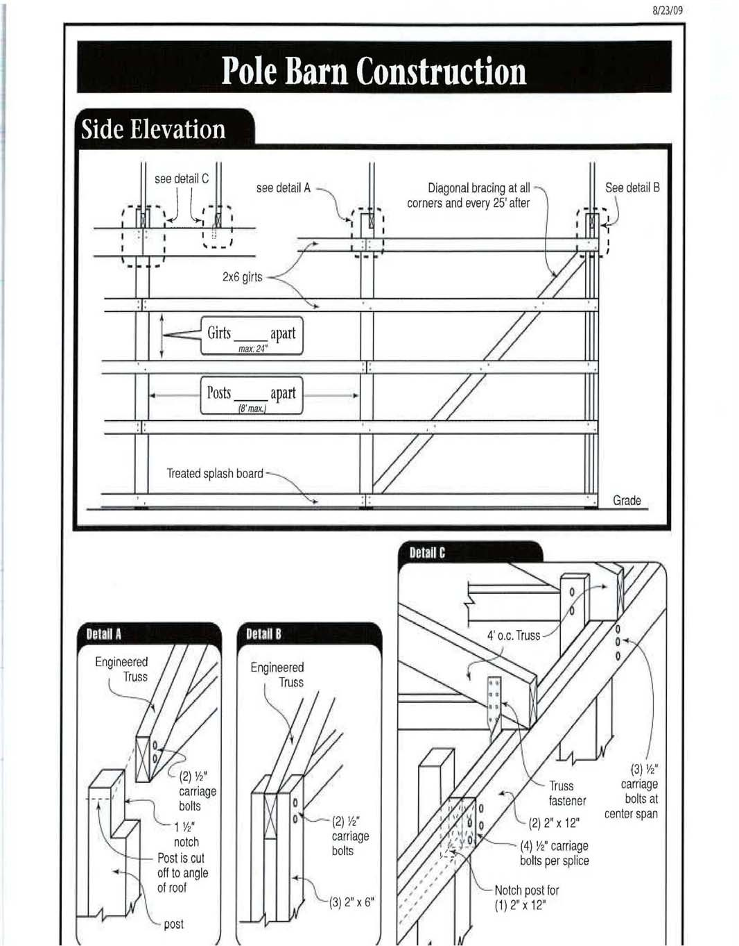

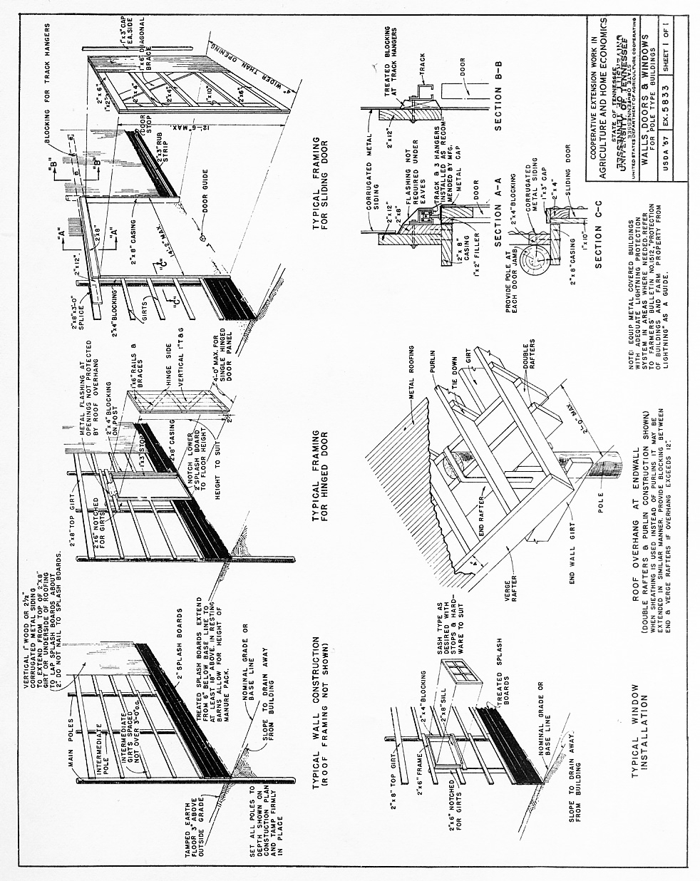

Page 6 of 6

